Experiment Number : 03 Date:

Control Statements in Java
Aim:
To understand and implement decision-making and looping control statements in Java.
PRE LAB EXERCISE
QUESTIONS
- List different control statements in Java.
Control statements in Java control the program flow. Examples include if, if-else, switch, for, while, do-while, break, and continue.

- Difference between for, while, and do-while loops.
for loop is used when iterations are known. while checks the condition before execution. do-while executes first, then checks the condition.
- What is the use of break and continue?
break terminates the loop or switch immediately. continue skips the current iteration of a loop and moves to the next iteration.
IN LAB EXERCISE
Objective:
To implement if-else and looping statements.
INPUT STATEMENT:
SCANNER CLASS
- The Scanner class in Java is used to read input from the user through the keyboard.
It is available in the package java.util.
- The Scanner object reads different types of input such as integer, float, double, and string and stores them in variables.
- To use the Scanner class, it must be imported before using it in the program.
SYNTAX:
- Scanner sc = new Scanner(System.in);
Commonly Used Scanner Methods:
- nextInt() – reads an integer value
- nextFloat() – reads a float value
- nextDouble() – reads a double value
- next() – reads a single word
- nextLine() – reads a complete line of text

PROGRAMS:
Program 1: Check Whether a Number is Positive
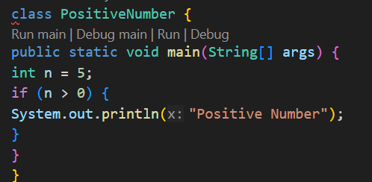
Output:
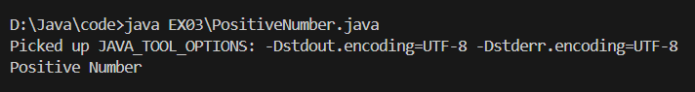

Program 2: Check Whether a Number is Even or Odd
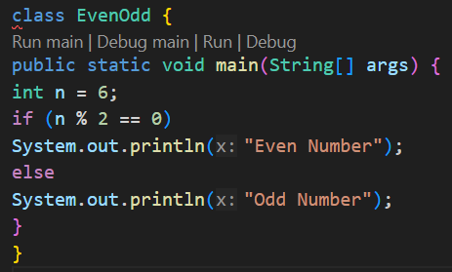
Output:
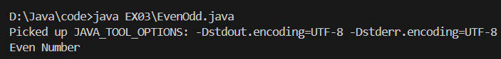
Program 3: Find Largest of Two Numbers
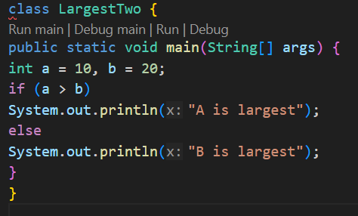
Output:
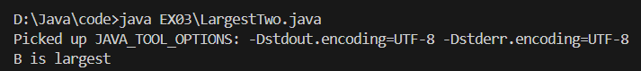

Program 4: Grade Calculation
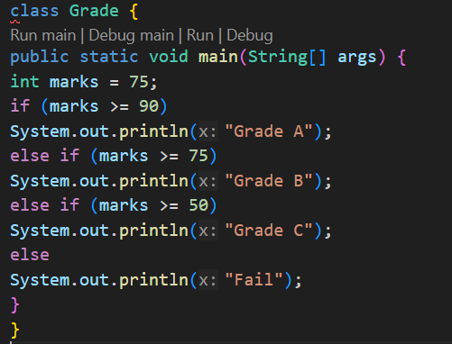
Output:
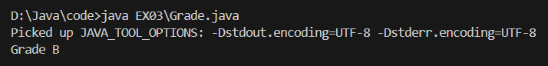

Program 5: Day of the Week
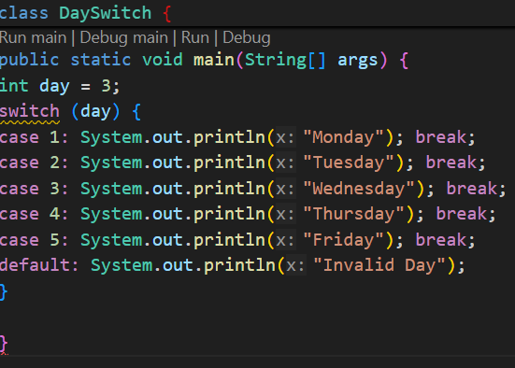
Output:
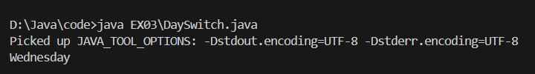

Program 6: Print Numbers from 1 to 5
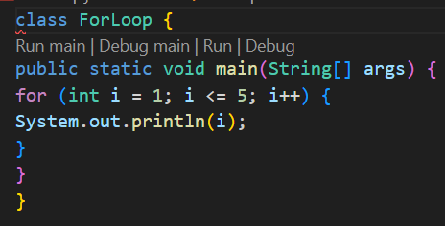

Output:
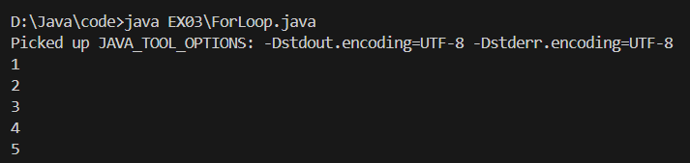
Program 7: Print Numbers from 1 to 5
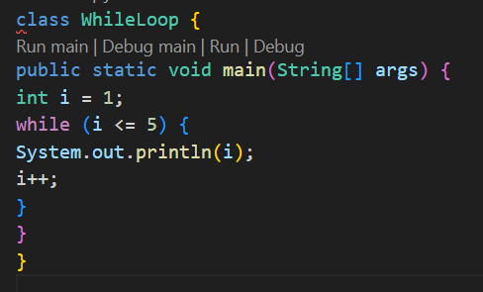
Output:
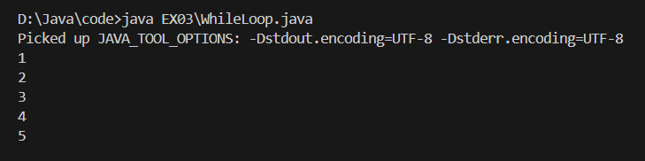

Program 8: Print Numbers from 1 to 5
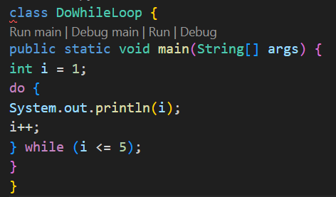
Output:
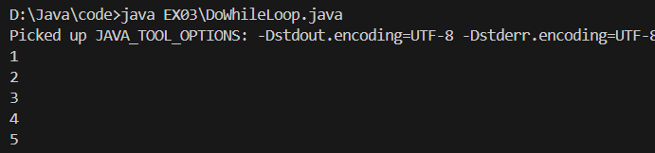
Program 10: Multiplication Table of a Number
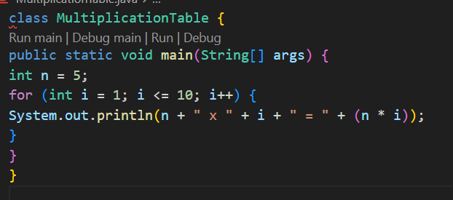Output:
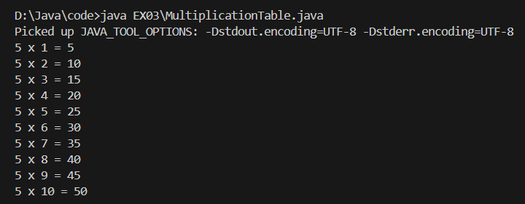

POST LAB EXERCISE
- What is the use of if statement?.
The if statement is used to test a condition. If the condition is true, the program executes the specified block of code.

- Difference between if-else and else-if ladder.
if-else chooses between two options. else-if ladder allows checking multiple conditions sequentially until one condition becomes true.

- Why is switch statement used?
The switch statement is used to select and execute one block of code from multiple choices based on the value of an expression.

- Difference between for, while, and do-while loops.
for loop combines initialization, condition, and update. while checks condition before running. do-while runs the loop once before checking the condition.

- Which loop executes at least once?
The do-while loop executes at least once because the condition is checked only after the loop body runs.

Result:

Thus the different control statements were executed successfully with expected output.

ASSESSMENT

Description | Max Marks | Marks Awarded
Pre Lab Exercise | 5
In Lab Exercise | 10
Post Lab Exercise | 5
Viva | 10
Total | 30
Faculty Signature

